
Adelaide North East District SAPSASA

Sapsasa Girls AFL state carnival nomination

Activity information sheet

AFL trials
Trials are run in a safe and supportive learning environment to select a district team to compete at the AFL State Sapsasa Carnival.
Students will be involved in drills and competitive scenarios to select a team based on the following criteria:

- Ability and game sense in the sport
- Teamwork
- Effort
- Willingness to listen and learn from feedback
- Positive attitude (including at school)

Eligibility: Trials are open to students in year 5 and 6 who wish to be considered for selection in the Sapsasa ANE district team to compete in the AFL Sapsasa State carnival.

Date(s): TBA – likely to start in Week 6 or 7 of term 3
Time: 4-5 pm
Venue: TBA

Transport: Parents/Caregivers are responsible for organising transport to and from the trials.
Requirements: Students must wear appropriate sporting attire (School PE top is required), football boots, sufficient food and drink along with a mouth guard.
Supervision: Students will be under the supervision of the teacher team official and other identified responsible persons (with appropriate WWCC) to ensure supervision ratios are met.
Contingency plans: If unforeseen circumstances mean the trials are unable to go ahead, families and schools will be notified as soon as possible. Trials will either be rescheduled if time permits, or an alternate venue will be organised.

AFL State Sapsasa Carnival details
The carnival is run by School Sport SA (Department for Education) for the 40 Sapsasa districts across South Australia, with a focus on students developing skills and learning through sport in a safe and supportive environment. District teams compete in a round robin style competition over 3 days.
Coach – Hadyn Smith (St Pius X)
Date: Monday October 27-Wednesday October 29
Time: 8 am to 3:30 pm
Venue: Barratt Reserve West Beach
Cost: $115.00 if selected in the team. There is no cost to trial.
Payment: Your school will invoice you prior to the carnival. Please pay directly to your child’s school.
Please contact your school to arrange a payment plan if required.
Supervision: The team will under the supervision of the teacher team official and other identified responsible persons (with appropriate WWCC) to ensure supervision ratios are met.
Transport and accommodation: Parents/Caregivers are responsible for organising transport and accommodation (if applicable) for the event.
Contingency plans: If unforeseen circumstances mean the carnival is unable to go ahead/interrupted, families and schools will be notified as soon as possible. The event will either be rescheduled if necessary or a modified program will be enacted under the supervision of the teacher team official.
Please note: All Department for Education School Sport SA events and venues are smoke and alcohol free.

How to nominate –
- Parents/Caregivers must nominate their child online by no later than Friday August 22.
- Students who have not nominated online before the trials will not be eligible to attend trials. This is to ensure supervision ratios are maintained for a safe environment.
- If you require support in completing the form, please contact your school Sapsasa rep.
To nominate, please complete the online form which can be accessed by using this QR code if using a mobile device or via the link https://forms.office.com/r/xNQwG9Eja0
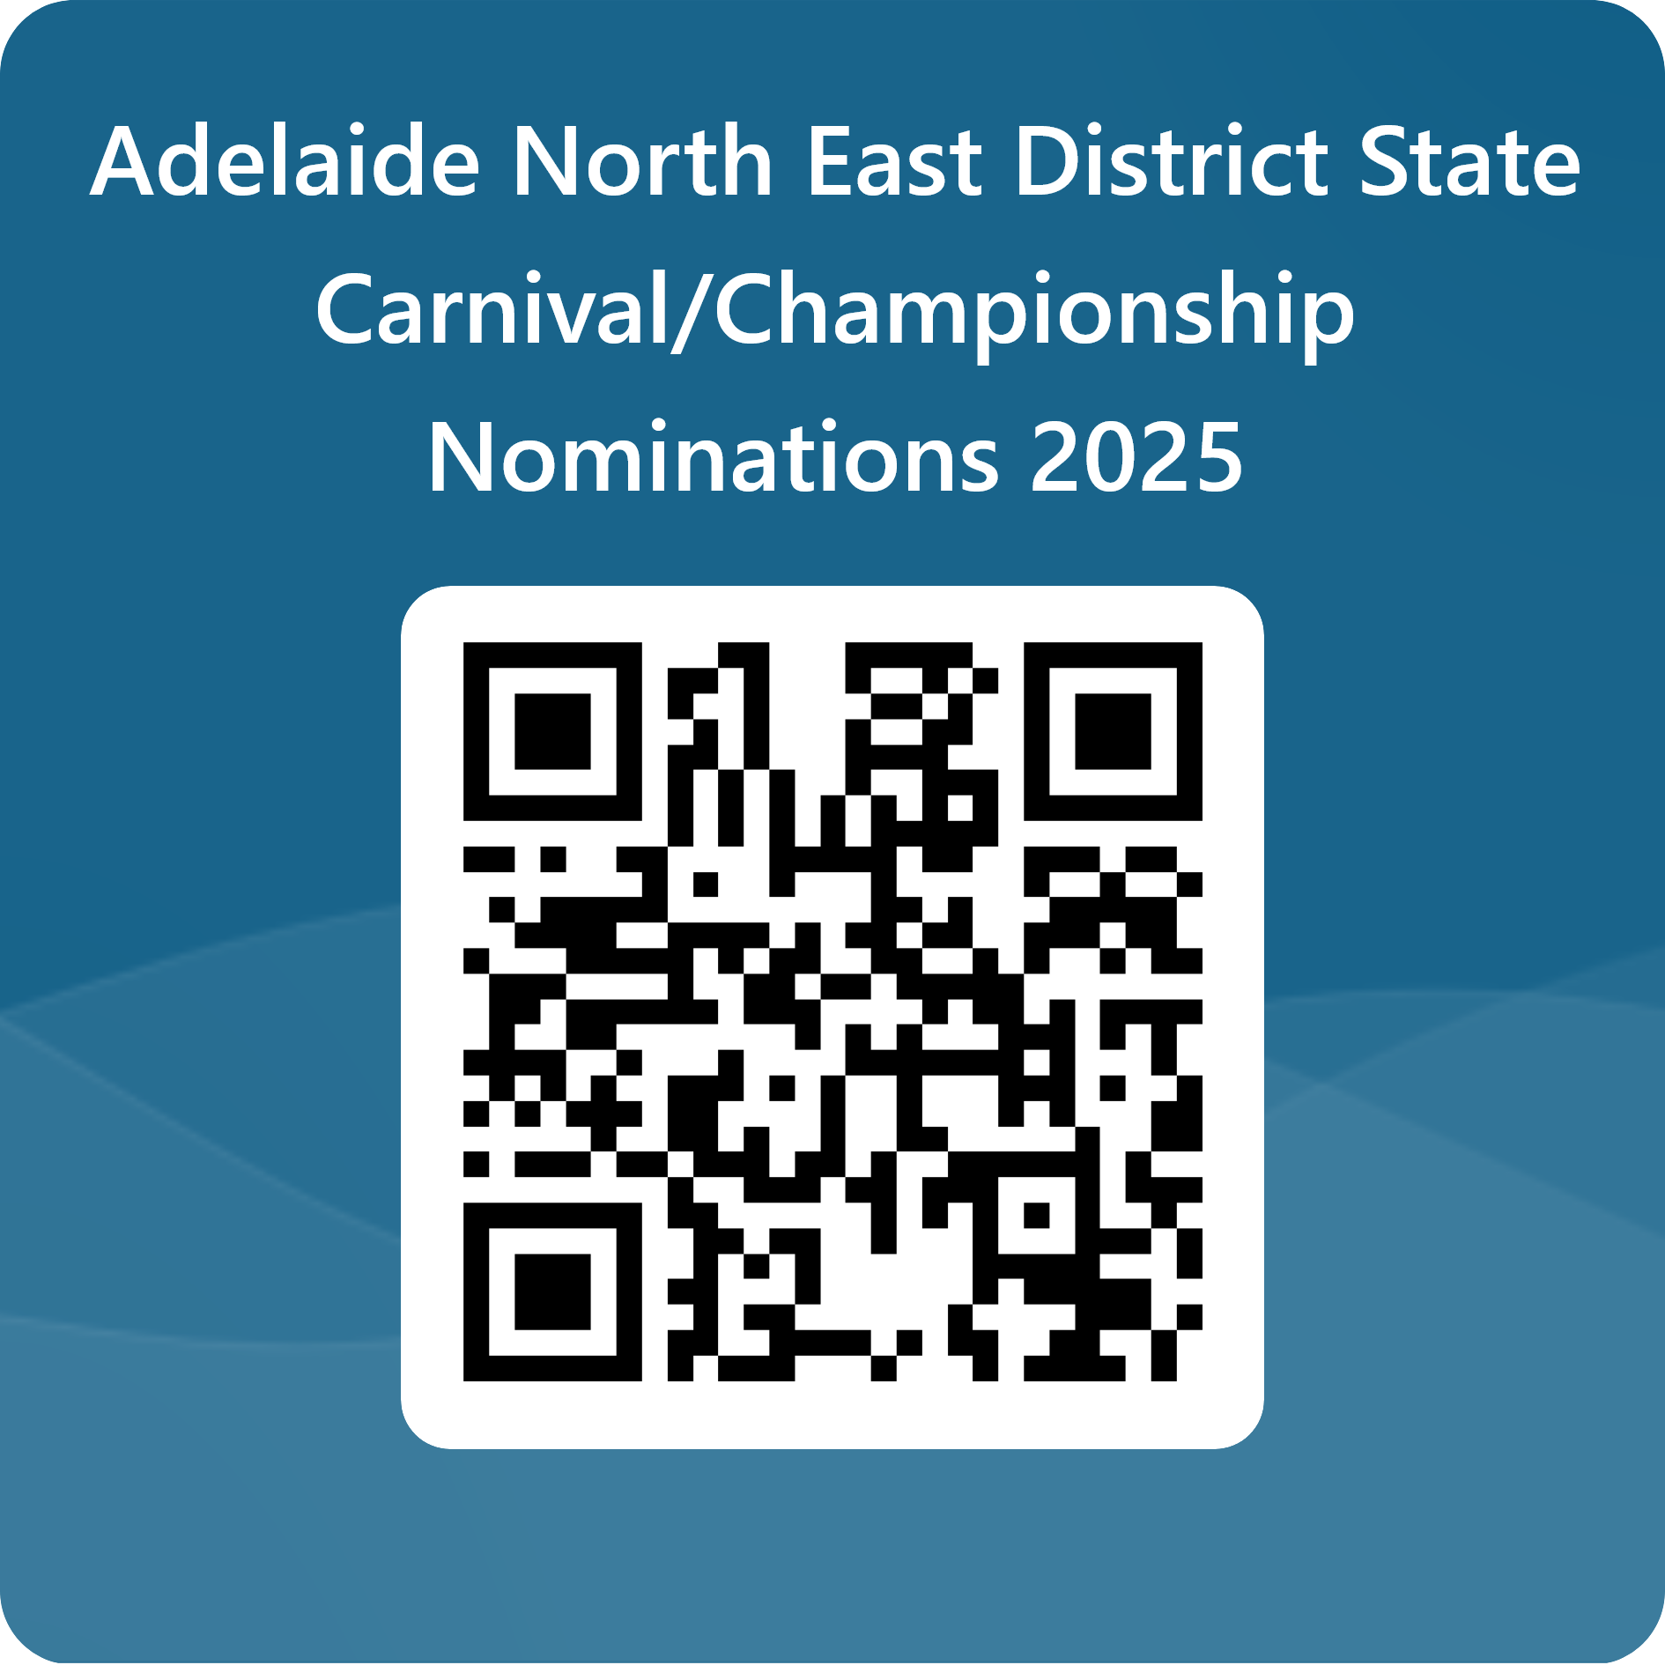

- Once you have submitted the form you will receive a confirmation email (please check junk email as well), a copy of the form will also be sent to the school as confirmation that you are nominating your child for AFL and will be retained by the school as a record of their involvement as per department records management policy and procedure.
- Please note the school has the right to not approve a child’s involvement in the carnival based on behaviour, attendance and other grounds as determined by the school.

Further information
Once a team has been selected, further details regarding the carnival and trainings will be provided.
For more information, please ask your school Sapsasa representative or contact the convenor
Name: Michelle Richter
Mobile: 0412270311
Email: Michelle.Richter373@schools.sa.edu.au

