# **A close-up of a sign Description automatically generated Adelaide North East District SAPSASA**

# Sapsasa Boys Cricket state carnival nomination

## Activity information sheet

### Cricket trials

Trials are run in a safe and supportive learning environment to select a district team to compete at the State Carnival.

Students will be involved in drills and competitive scenarios to select a team based on the following criteria:

* Ability and game sense in the sport
* Teamwork
* Effort
* Willingness to listen and learn from feedback
* Positive attitude (including at school)

Eligibility: Trials are open to students in year 5 and 6 (boys must be nominated by their school) who wish to be considered for selection in the Sapsasa Adelaide North East district team to compete in the Cricket Sapsasa State carnival.

PLEASE NOTE- Due to the popularity of the Cricket carnival, Schools may only send 6 boys to the trial. Students will be selected by each individual School Sport contact. Please only nominate if your school has selected you to trial.

Trial dates: Week 1,2,3 of Term 4. Day TBA

Venue: TBA

Time: 4pm-5:15pm

*Please note that the squad will be reduced after each trial and School Sport contacts will pass on this information. I will also send an email to parents.*

Transport: Parents/Caregivers are responsible for organising transport to and from the trials.

Requirements: Students must wear appropriate sporting attire (PE top is required please but cricket pants can be worn. Students must have their own bat and protective gear. (If you do not have this, please ask your school to assist you.)

**Supervision:** Students will be under the supervision of the teacher team official and other identified responsible persons (with appropriate WWCC) to ensure supervision ratios are met.

Contingency plans: If unforeseen circumstances mean the trials are unable to go ahead, families and schools will be notified as soon as possible. Trials will either be rescheduled if time permits, or an alternate venue will be organised.

### Cricket State Sapsasa Carnival details

The carnival is run by School Sport SA (Department for Education) for the 40 Sapsasa districts across South Australia, with a focus on students developing skills and learning through sport in a safe and supportive environment. District teams compete in a round robin style competition over 3 days.

Coach: TBA

Date: Monday Nov 24-Wednesday Nov 26

Time: 8 am to 3:30 pm

Venue: Various venues in Adelaide TBA

Cost: $115.00 if selected in the team

Payment: Refer to the invoice for payment details if selected for the team.

Please contact your school to arrange a payment plan if required.

Supervision: The team will under the supervision of the teacher team official and other identified responsible persons (with appropriate WWCC) to ensure supervision ratios are met.

Transport and accommodation: Parents/Caregivers are responsible for organising transport and accommodation (if applicable) for the event.

Contingency plans: If unforeseen circumstances mean the carnival is unable to go ahead/interrupted, families and schools will be notified as soon as possible. The event will either be rescheduled if necessary or a modified program will be enacted under the supervision of the teacher team official.

**Please note**: All Department for Education School Sport SA events and venues are smoke and alcohol free.

### How to nominate –

* Parents/Caregivers must nominate their child online by no later than **Monday October 13**
* Students who have not nominated online before the trials will not be eligible to attend trials. This is to ensure supervision ratios are maintained for a safe environment.
* If you require support in completing the form, please contact your school Sapsasa rep.

To nominate, please complete the online form which can be accessed by using this QR code if using a mobile device or via the link <https://forms.office.com/r/xNQwG9Eja0>

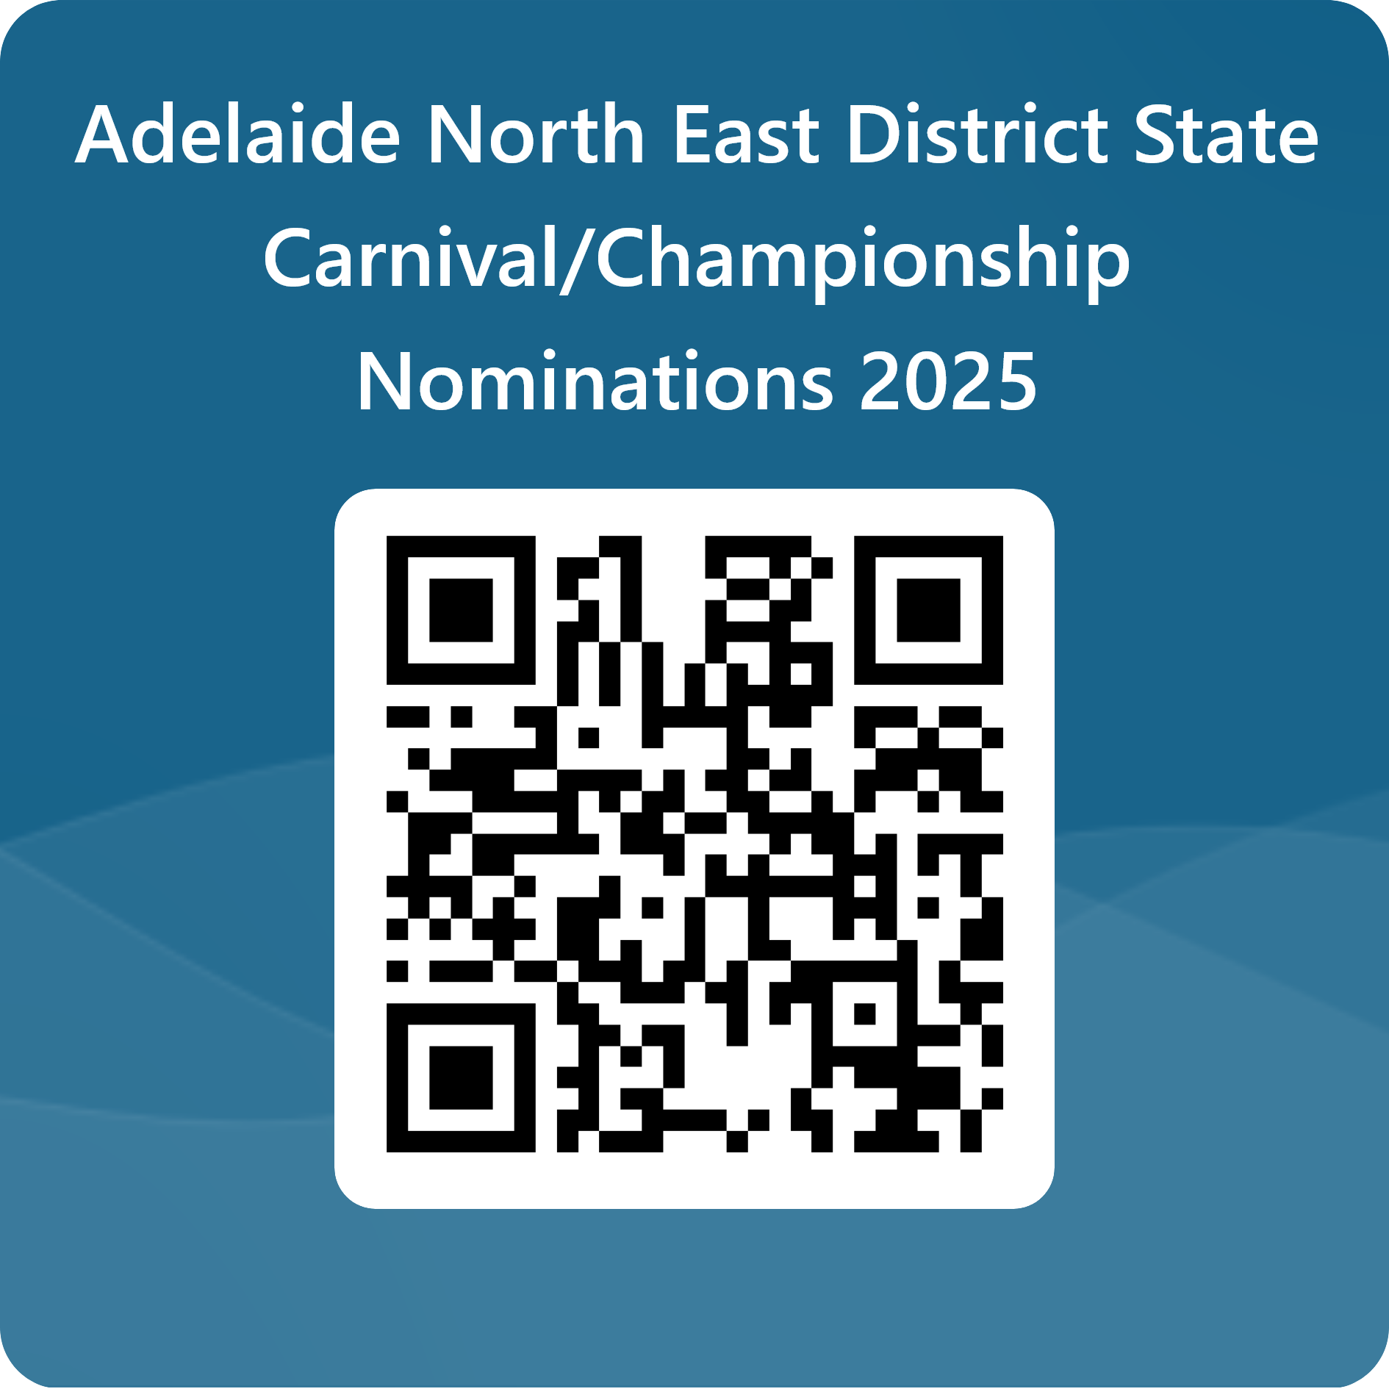

* Once you have submitted the form you will receive a confirmation email (please check junk email as well), a copy of the form will also be sent to the school as confirmation that you are nominating your child for Cricket trials and will be retained by the school as a record of their involvement as per department records management policy and procedure.
* Please note the school has the right to not approve a child’s involvement in the carnival based on behaviour, attendance and other grounds as determined by the school.

### Further information

Once a team has been selected, further details regarding the carnival and trainings will be provided.

**Name: Michelle Richter**

**Mobile: 0412270311**

**Email:** [**Michelle.Richter373@schools.sa.edu.au**](mailto:Michelle.Richter373@schools.sa.edu.au)