# **Adelaide North East District SAPSASA**

# Sapsasa Tennis state carnival nomination

## Activity information sheet

### Adelaide North East Tennis trials

Trials are run in a safe and supportive learning environment to select a district team to compete at the Tennis State Sapsasa Carnival.

Students will be involved in drills and competitive scenarios to select a team based on the following criteria:

* Ability and game sense in the sport
* Teamwork- doubles play
* Effort
* Willingness to listen and learn from feedback.
* Positive attitude (including at school)
* Current UTR and division played.
* Results of match play at trials.

Eligibility: Trials are open to students in year 5 and 6 who play Yellow or Green ball and wish to be considered for selection in the Sapsasa ANE district team to compete in the Tennis Sapsasa State carnival.

Trial Date(s):

Wednesdays 24 September (Week 10 Term 3), 15, 22 and 29 October (Week 1,2,3 Term 4)

Time: 4-5 pm

Venue: Prospect Tennis Club

Transport: Parents/Caregivers are responsible for organising transport to and from the trials.

Requirements: Students must wear appropriate sporting attire (PE uniform is required), bring sunscreen, hat, sufficient food and drink along with a tennis racquet

**Supervision:** Students will be under the supervision of the teacher team official and other identified responsible persons (with appropriate WWCC) to ensure supervision ratios are met.

Contingency plans: If unforeseen circumstances mean the trials are unable to go ahead, families and schools will be notified as soon as possible. Trials will either be rescheduled if time permits, or an alternate venue will be organised.

### Tennis State Sapsasa Carnival details

The carnival is run by School Sport SA (Department for Education) for the 40 Sapsasa districts across South Australia, with a focus on students developing skills and learning through sport in a safe and supportive environment. District teams compete in a round robin style competition over 3 days.

Coach: Josh Weston- Mawson Lakes

Date: Monday November 10-Wednesday November 12

Time: 9 am to 3 pm

Venue: TTG Tennis club TBC

Cost: $115.00 if selected in the team (includes hat or visor)

Payment: Your school will invoice you and you are required to pay directly to them.

Please contact your school to arrange a payment plan if required.

Supervision: The team will under the supervision of the teacher team official and other identified responsible persons (with appropriate WWCC) to ensure supervision ratios are met.

Transport and accommodation: Parents/Caregivers are responsible for organising transport and accommodation (if applicable) for the event.

Contingency plans: If unforeseen circumstances mean the carnival is unable to go ahead/interrupted, families and schools will be notified as soon as possible. The event will either be rescheduled if necessary or a modified program will be enacted under the supervision of the teacher team official.

**Please note**: All Department for Education School Sport SA events and venues are smoke and alcohol free.

### How to nominate –

* Parents/Caregivers must nominate their child online by no later than **Tuesday September 21**
* Students who have not nominated online before the trials will not be eligible to attend trials. This is to ensure supervision ratios are maintained for a safe environment.
* If you require support in completing the form, please contact your school Sapsasa rep.

To nominate, please complete the online form which can be accessed by using this QR code if using a mobile device or via <https://forms.office.com/r/xNQwG9Eja0>

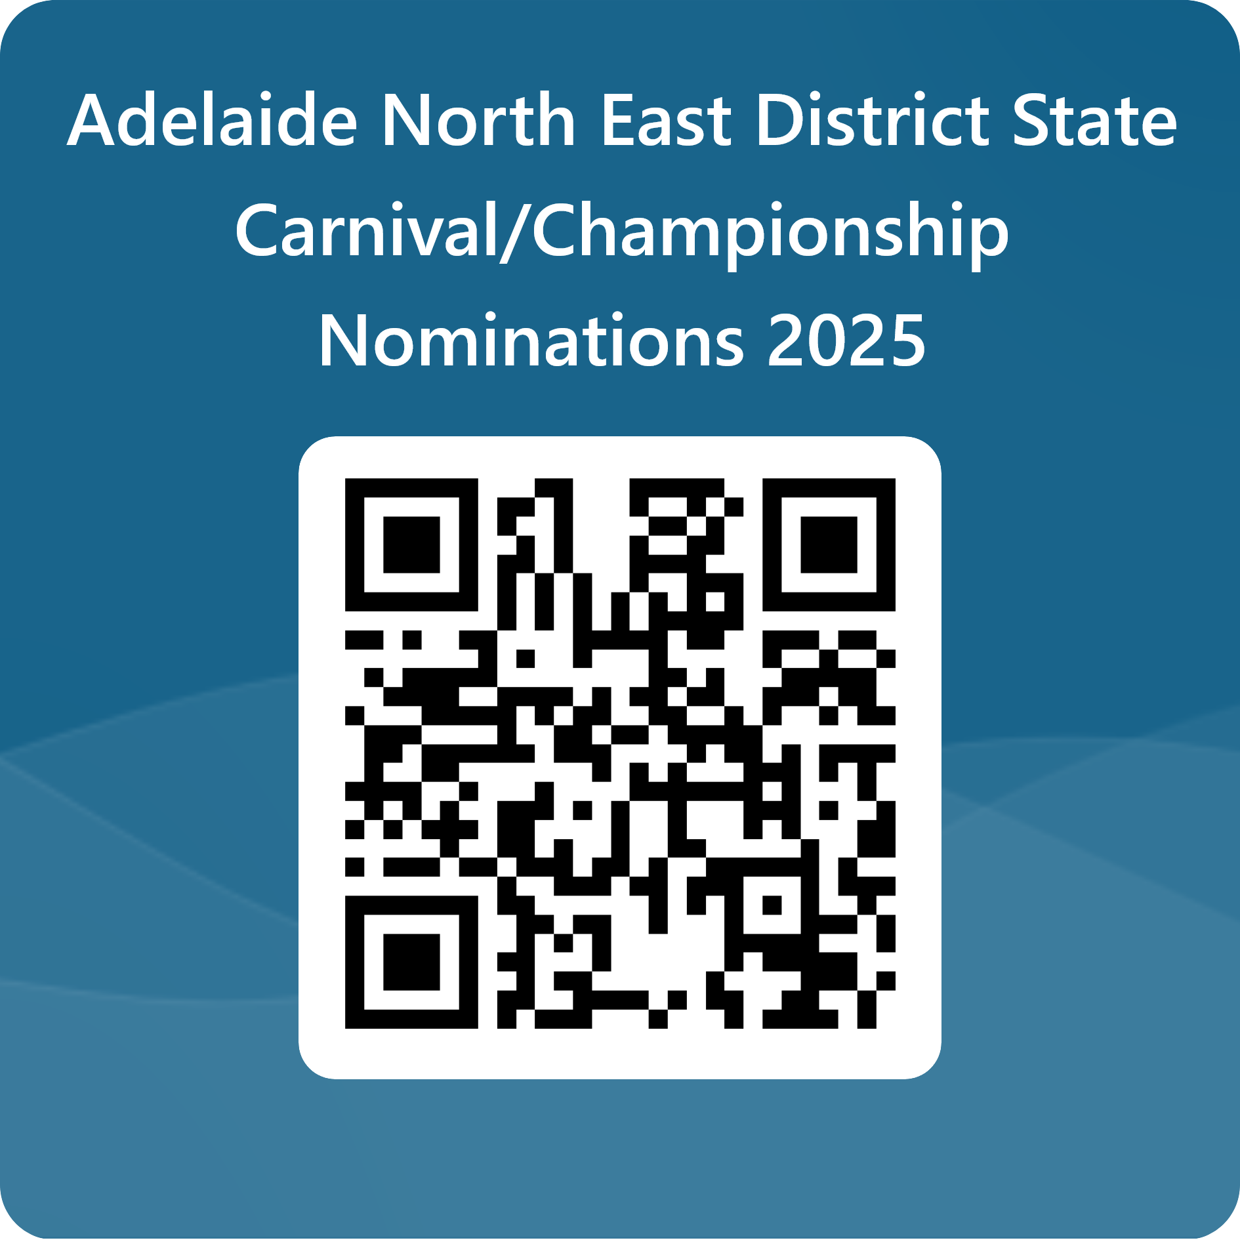

* Once you have submitted the form you will receive a confirmation email, a copy of the form will also be sent to the school as confirmation that you are nominating your child and will be retained by the school as a record of their involvement as per department records management policy and procedure.
* Please note the school has the right to not approve a child’s involvement in the carnival based on behaviour, attendance and other grounds as determined by the school.

### Further information

Once a team has been selected, further details regarding the carnival and training will be provided.

For more information, please ask your school Sapsasa representative or contact the convenor.

**Name: Michelle Richter**

**Mobile: 0412270311**

**Email:** [**Michelle.Richter373@schools.sa.edu.au**](mailto:Michelle.Richter373@schools.sa.edu.au)